**Chapter 3: Bipolar Junction Transistor**

Table of Contents

3.2 Construction 2

3.3 Operation 3

3.4 Common Base Configuration 4

3.5 Common Emitter Configuration 6

## 3.2 Construction

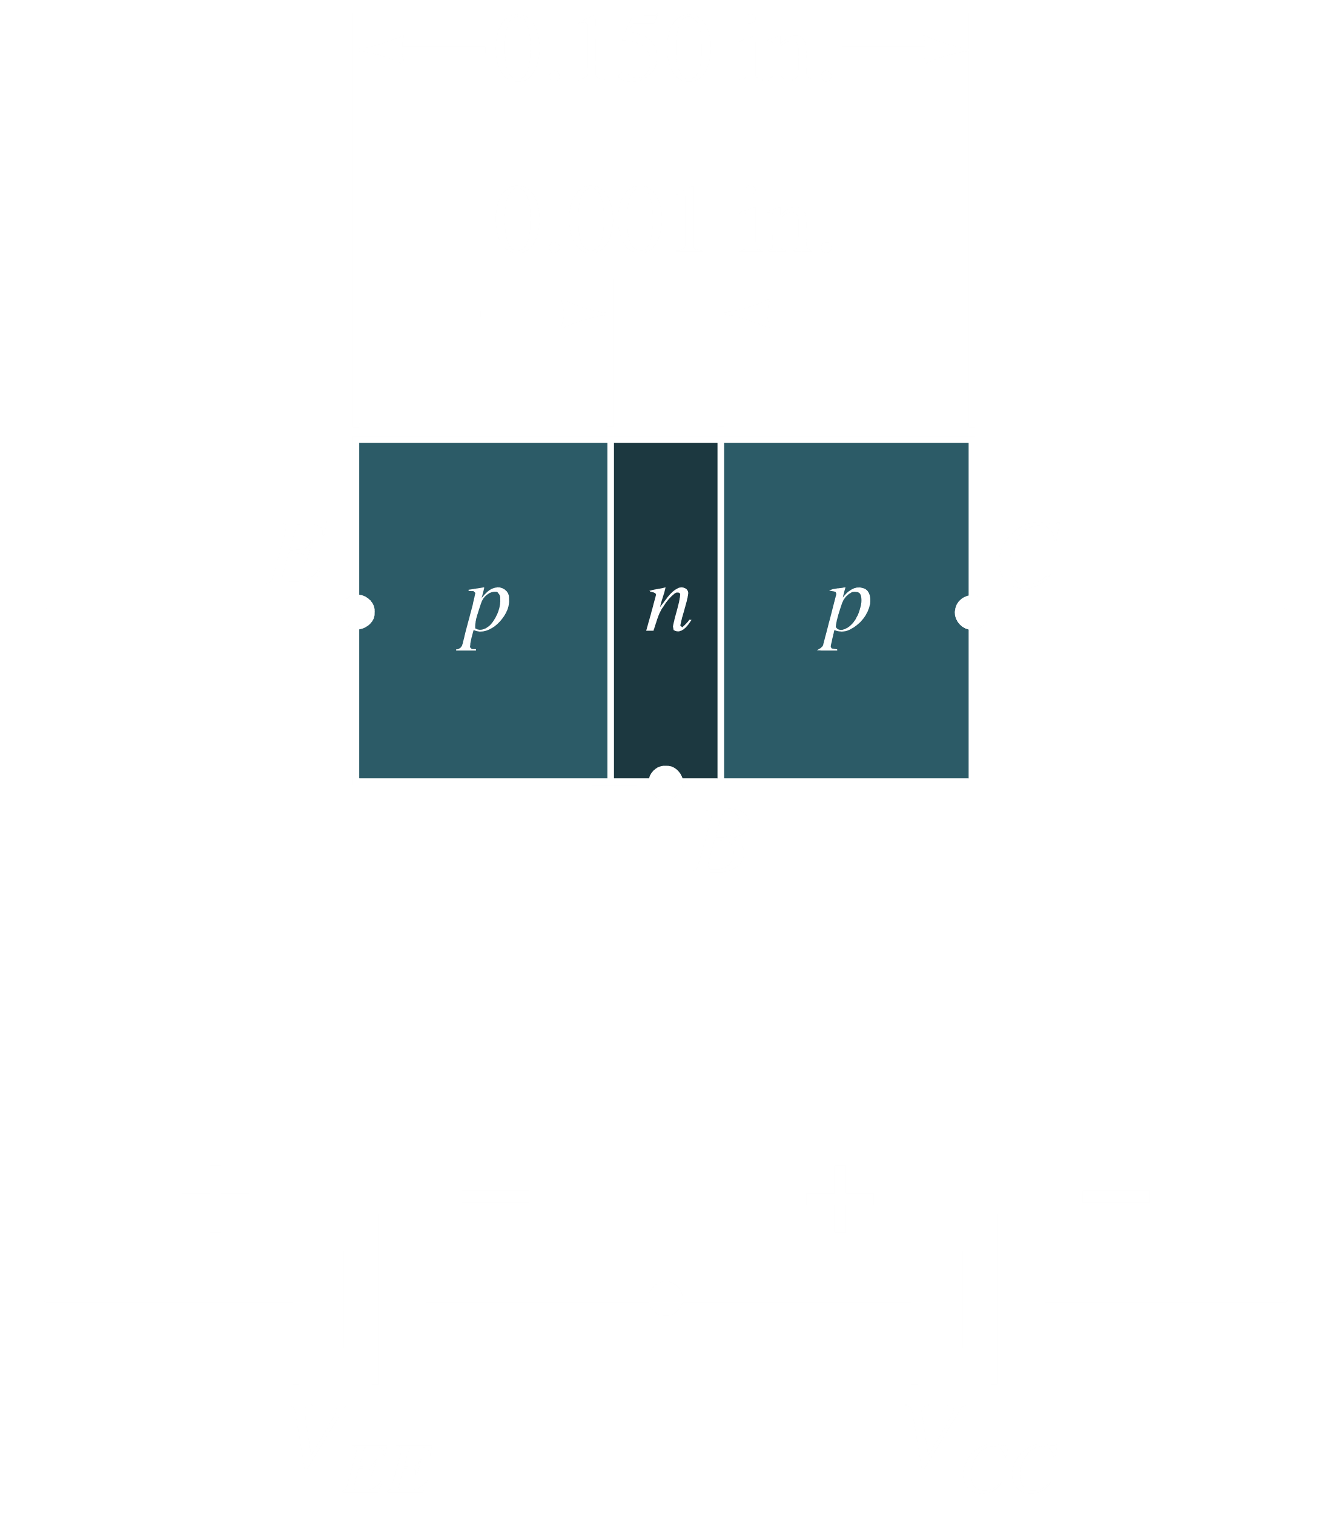

* Transistor – three-layer semiconductor
* Consists of either two n-type and one p-type layers (npn) or two p-type and one n-type layers (pnp)
* Outer layers are much thicker than central layer
* Emitter layer is heavily doped. Collector layer lightly doped. Base layer very lightly doped to decrease conductivity.
* Bipolar – both holes and electrons participate in injection process

## 3.3 Operation

* Forward – Reverse Biased – Active
* Holes being pushed from emitter side since forward biased
* At 0.7V, depletion region overcome
* Holes from emitter push into base, but base is really small so very few are pulled through the base connection ( $I_{B}$ is small)
* Holes are attracted by collector side since reverse biased. Overcome depletion region. Most flow into collector ( $I_{C}$ is large). $I_{C}$ consists of majority carriers from emitter and minority carriers from base (leakage current).
* Small current that is enough to allow depletion region between emitter and base to be overcome allows much larger current to flow through collector (amplification)
$I_{E}=I_{B}+I_{C}$

* For npn, reverse biases and exact same thing occurs with roles of holes and electrons being reversed. Direction of current reversed.



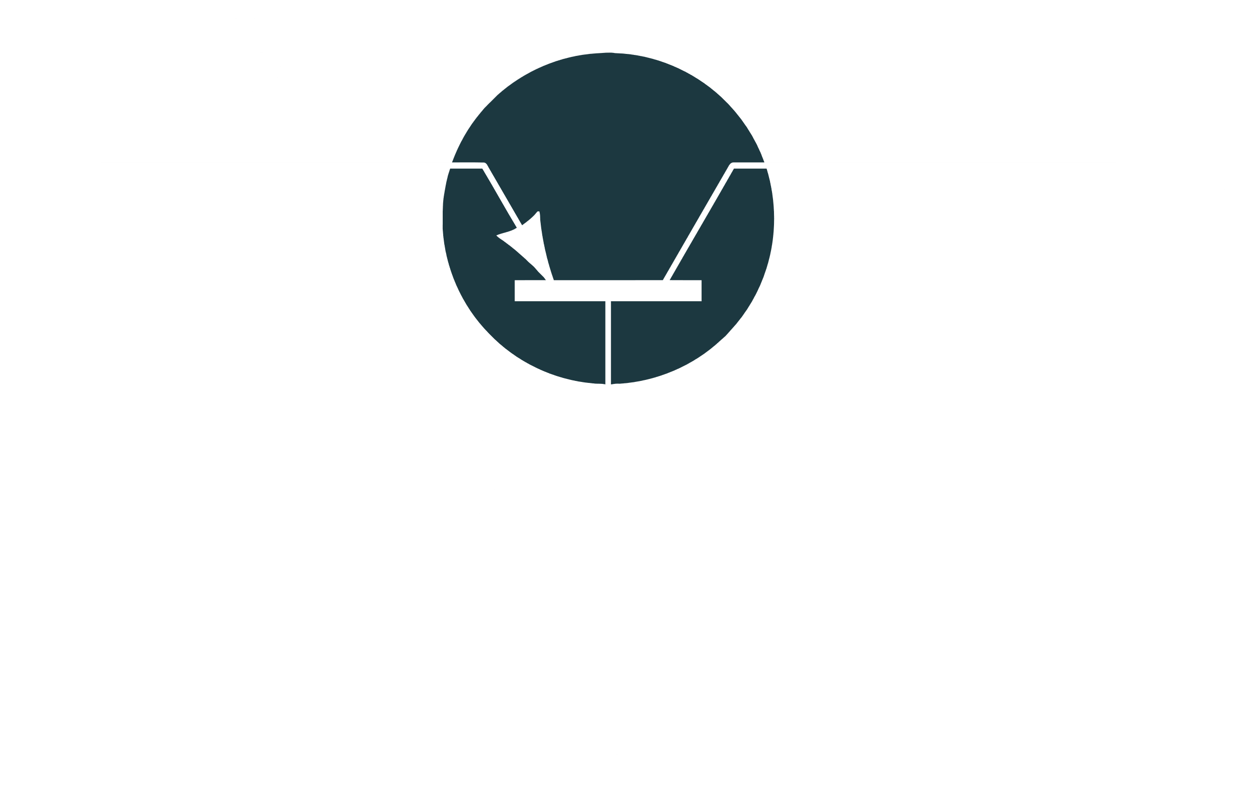 

## 3.4 Common Base Configuration

* Base is common to both input and output side
* Base is generally grounded
* Forward – Reverse bias – active
* Reverse – Forward Bias depletion region of emitter side increases so worthless
* Forward – Forward Bias – holes from both sides pushed towards each other; heavy current flow – on switch
* Reverse – Reverse bias – only minority carriers from base flow – off switch



* $I_{E}$ begins to flow when $V_{BE}$ is large enough to allow
* $V_{CB}$ larger – more attraction for holes – larger $I_{E}$



* Active region obvious
* Saturation – notice $V_{CB}$ is negative meaning bias flipped
* Cutoff region – $I_{E}=0$ so no input so no output

$α=\frac{I_{C}}{I_{E}}$

$β=\frac{I_{C}}{I_{B}}$

## 3.5 Common Emitter Configuration



* Emitter common to input and output terminals
* Input current is $I_{B}$ and input voltage is $V_{BE}$

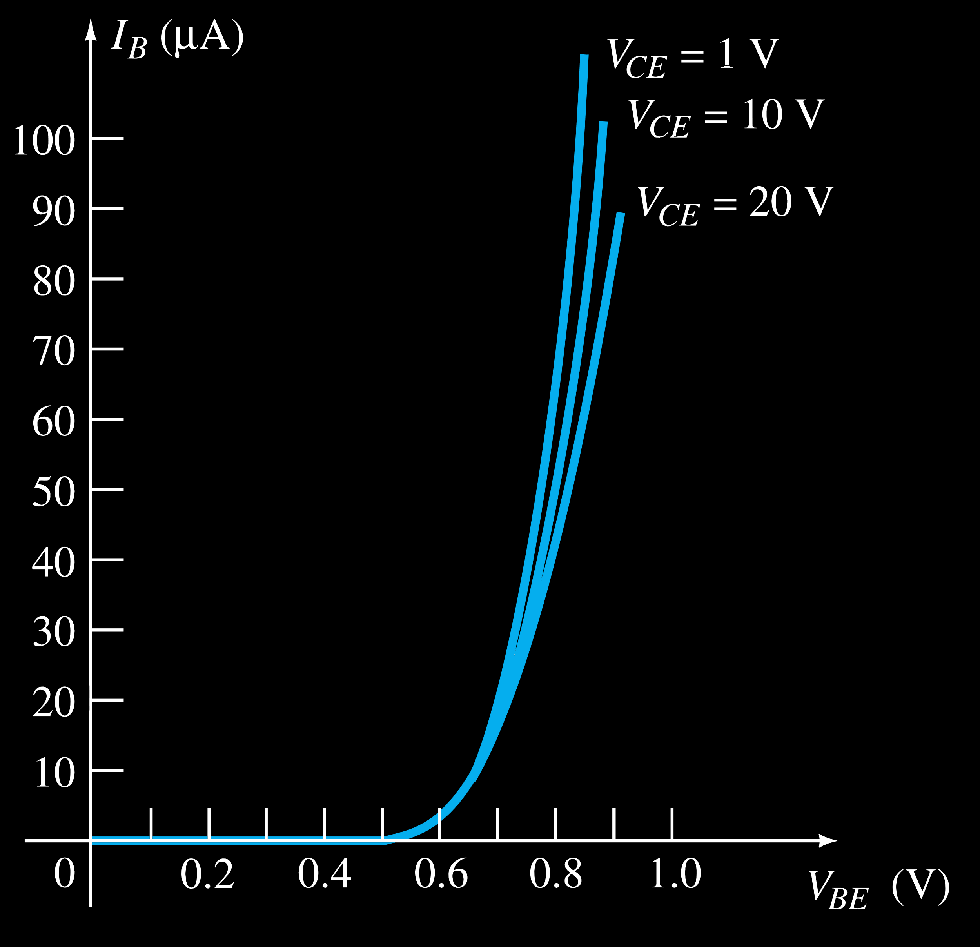

* Output current is $I_{C}$ and output voltage is $V_{CE}$

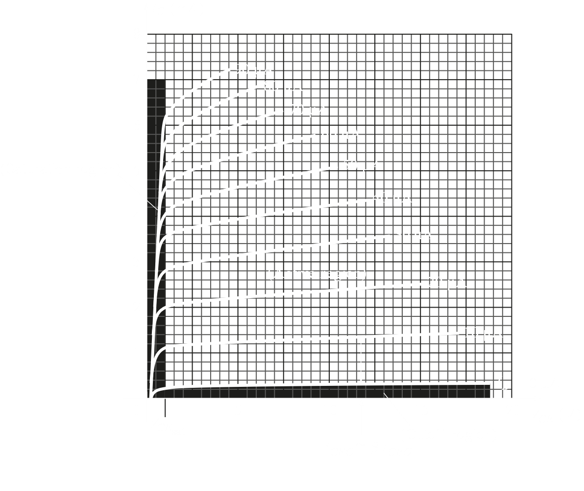

* $V_{CE}$ influences $I_{C}$. Lines not horizontal
* Active region used to amplification
* Cutoff region less obvious; $I_{B}=0$ but still some input – no clue why doe